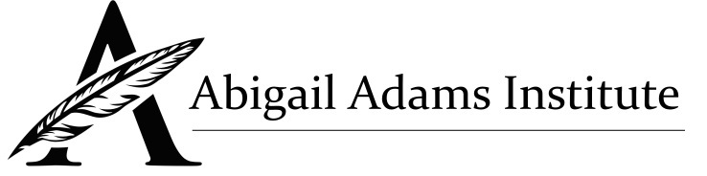

Man and Woman, Body and Soul in the Western Tradition
Erika Bachiochi, JD.
Angela Franks, Ph.D.

Course Schedule:

Day One:  Ancient and Medieval Foundations | Monday August 5th  9:30am start.
Day Two:  Modern Quest for Liberty and Equality | Tuesday August 6th  9:30am start.
Day Three:  Republican Motherhood, Separate Spheres, and the Early American Cause of Women's Rights | Wednesday August 7th  9:30am start.
Day Four:  Twentieth-Century Feminism | Thursday August 8th  9:30am start.
Day Five:  Contemporary Recovery in Metaphysics and Politics | Friday August 9th  9:30am start.

